Exploring Genetic Variation in a Caffeine Metabolism Gene
Part Two: RFLP and SNP Analysis

Background
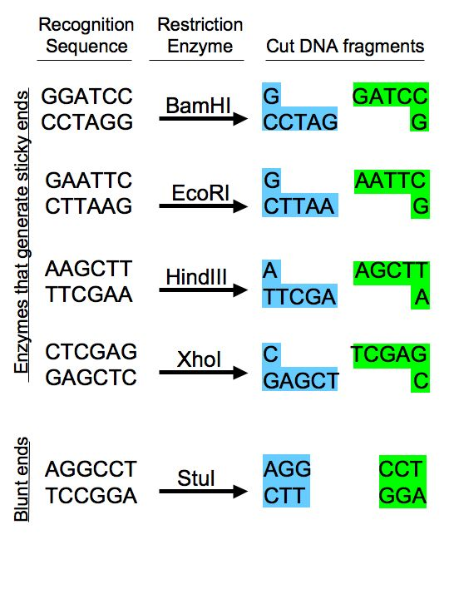Figure 1. Diagram of restriction sequences.

Restriction endonucleases (or restriction enzymes) are some of the most powerful tools in modern molecular biology. These enzymes, produced by bacteria, interact with recognition sequences, highly specific nucleotide sequences
in DNA molecules (Figure 1). They then cut both strands of the double-stranded DNA, creating DNA restriction fragments. Because the recognition sequence is very specific and different DNAs will have different numbers of these sequences, digestion of different DNAs with the same enzyme may yield differently sized restriction fragments. This restriction analysis can be used as a fingerprint to distinguish DNA molecules from each other. To date, more than 2500 restriction enzymes have been isolated, and many are commercially available, offering a wide variety of options for cutting DNA molecules at different sites.

In this lab, we will digest your PCR product of the amplified CYP1A2 gene sequence and examine it by using certain restriction enzymes. This will generate DNA fragments of a certain length, called restriction fragment length polymorphisms (RFLPs). We can analyze this data to determine the genotype indicated and therefore make predictions about the phenotype. You will then be able to determine whether your model data set represents a homozygote or a heterozygote and whether this indicates that they will metabolize caffeine quickly or slowly.

Safety Note
Ethidium bromide is a carcinogen that we will use to stain the DNA in the gel. When ethidium bromide is visualized under UV light, it fluoresces orange. Make sure to wear gloves when working with ethidium bromide.

Protocol
1. In the interest of time, we will assume that your PCR worked and proceed with the next step of setting up a restriction digest. Fill in the columns on the right in the chart below to set up your restriction digests for a total volume of 30μL each.

Component | Stock Concentration | Final Concentration | SacI Digest | ApaI Digest | No enzyme
PCR |  |  | 15μL | 15μL | 15μL
CutSmart Buffer | 10X | 1X
Water
Enzyme: SacI | 10 units/μL | 5 units
Enzyme: ApaI | 10 units/μL | 5 units

2. Set up your digests (or negative control) in 0.65 mL microfuge tubes. Label them clearly with your initials and indicate them as either SacI or ApaI or no enzyme. Gently flick the tube to mix, centrifuge briefly, and incubate the SacI digest at 37ºC for 1 hr and the ApaI and no enzyme tubes at room temperature for 1hr.
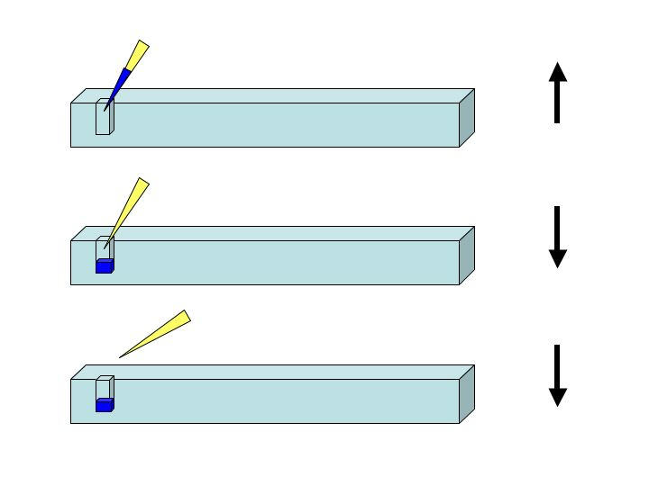Figure 2. How to load an agarose gel. Once your sample is in the tip, submerge the tip in the buffer and put it gently into the well. Push the sample out of the tip (go down to the hard stop). Keep your thumb down until you remove the tip from the liquid. Otherwise, you will suck water back up into the tip. The arrows on the right indicate the direction of the plunger at each point.

3. While the digest is incubating, prepare a 1.2% agarose gel (100mL in 1X TAE) with 1:20000 ethidium bromide and 1L of 1X TAE. Make sure to wear gloves when using ethidium bromide.

4. When the digest is complete, add 6μL of DNA loading dye to each tube and pipet up and down to mix. Load 15μL of each sample into a different well of the gel in the following order: no enzyme; SacI; ApaI. Make sure to load 5μL 100bp ladder (https://www.neb.com/products/n3231-100-bp-dna-ladder) as well. See the figure 1 if you need help.

5. Run the gel at 150 volts until the blue dye is about ¾ down the gel. Image the gel on the UV transilluminator.

Concept Check:
Below is the CYP1A2 sequence. Recall that there are two CYP1A2 alleles that differ in sequence as the result of a Single Nucleotide Polymorphism (SNP). The underlined and bolded base at position 494 indicates the SNP in this allele.

Allele 1

GGA GAGCGATGGG GAGGGCTTCC CCCTTAGCAC AAGGGCAGCC CTGGCCCTGG 53
CTGAAGCCCA ACCCCAACCT CCAAGACTGT GAGAGGATGG GGACTCATCC CTGGAGGAGG 113
TGCCCCTCCT GGTATTGATA AAGAATGCCC TGGGGAGGGG GCATCACAGG CTATTTGAAC 173
CAGCCCTGGG ACCTTGGCCA CCTCAGTGTC ACTGGGTAGG GGGAACTCCT GGTCCCTTGG 233
GTATATGGAA GGTATCAGCA GAAAGCCAGC ACTGGCAGGG ACTCTTTGGT ACAATACCCA 293
GCATGCATGC TGTGCCAGGG GCTGACAAGG GTGCTGTCCT TGGCTTCCCC ATTTTGGAGT 353
GGTCACTTGC CTCTACTCCA GCCCCAGAAG TGGAAACTGA GATGATGTGT GGAGGAGAGA 413
GCCAGCGTTC ATGTTGGGAA TCTTGAGGCT CCTTTCCAGC TCTCAGATTC TGTGATGCTC 473
AAAGGGTGAG CTCTGTGGGC A 494
CAGGACGCAT GGTAGATGGA GCTTAGTCTT TCTGGTATCC AGCTGGGAGC CAAGCACAGA 554
ACACGCATCA GTGTTTATCA AATGACTGAG GAAATGAATG AATGAATGTC TCCATCTCAA 614
CCCTCAGCCT GGTCCCTCCT TTTTTCCCTG CAGTTGGTAC AGATGGCATT GTCCCAGTCT 674
GTTCCCTTCT CGGCCACAGA GCTTCTCCTG GCCTCTGCCA TCTTCTGCCT GGTATTCTGG 734
GTGCTCAAG 743

The SNP site is variable, of course, and the alternate allele of CYP1A2 has a C nucleotide in place of an A. This alternate allele sequence is shown below.

Allele 2

GGA GAGCGATGGG GAGGGCTTCC CCCTTAGCAC AAGGGCAGCC CTGGCCCTGG 53
CTGAAGCCCA ACCCCAACCT CCAAGACTGT GAGAGGATGG GGACTCATCC CTGGAGGAGG 113
TGCCCCTCCT GGTATTGATA AAGAATGCCC TGGGGAGGGG GCATCACAGG CTATTTGAAC 173
CAGCCCTGGG ACCTTGGCCA CCTCAGTGTC ACTGGGTAGG GGGAACTCCT GGTCCCTTGG 233
GTATATGGAA GGTATCAGCA GAAAGCCAGC ACTGGCAGGG ACTCTTTGGT ACAATACCCA 293
GCATGCATGC TGTGCCAGGG GCTGACAAGG GTGCTGTCCT TGGCTTCCCC ATTTTGGAGT 353
GGTCACTTGC CTCTACTCCA GCCCCAGAAG TGGAAACTGA GATGATGTGT GGAGGAGAGA 413
GCCAGCGTTC ATGTTGGGAA TCTTGAGGCT CCTTTCCAGC TCTCAGATTC TGTGATGCTC 473
AAAGGGTGAG CTCTGTGGGC C 494
CAGGACGCAT GGTAGATGGA GCTTAGTCTT TCTGGTATCC AGCTGGGAGC CAAGCACAGA 554
ACACGCATCA GTGTTTATCA AATGACTGAG GAAATGAATG AATGAATGTC TCCATCTCAA 614
CCCTCAGCCT GGTCCCTCCT TTTTTCCCTG CAGTTGGTAC AGATGGCATT GTCCCAGTCT 674
GTTCCCTTCT CGGCCACAGA GCTTCTCCTG GCCTCTGCCA TCTTCTGCCT GGTATTCTGG 734
GTGCTCAAG 743

1. The restriction enzyme SacI has the recognition sequence GAGCTC. Find this site in both allele sequences above and highlight it. (Hint: this is not far from the SNP.)
2. SacI cuts between the T and the last C.
A. If SacI cuts at this site, how many pieces of DNA do you get? ___________________

B. How big is each piece? __________________ bp & __________________ bp

3. The restriction enzyme ApaI cuts at the sequence GGGCCC. Look for this sequence at the SNP site in Allele 2 and highlight it with a different color. Notice that this site does NOT occur in Allele 1 due to the SNP variation.

A. If ApaI only is used to digest allele 2, how many pieces of DNA do you get? _______________

B. ApaI cuts between the penultimate and final C of its restriction site. How big will each piece be?

__________________ bp & __________________ bp

4. Everyone has two CYP1A2 alleles (a maternal copy and a paternal copy). Thus, individuals may be homozygous for either allele 1 or 2, or heterozygous. Your PCR samples should contain an equal mix of amplified CYP1A2 sequences from both your paternal and maternal alleles. Below are three agarose gel diagrams. Sketch the positions (sizes) of CYP1A2 restriction fragments that you would expect to observe based on the possible genotypes indicated.

Homozygous Allele 1 Homozygous Allele 2
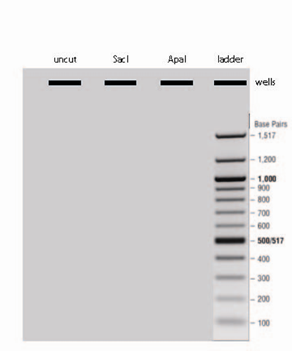
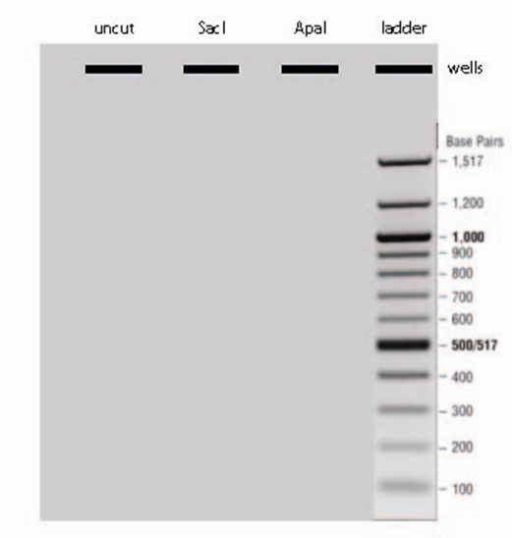

Heterozygous

Analysis
Finally, it is time to determine whether you are a fast or slow caffeine metabolizer. Those who have are homozygous for Allele 1 are considered fast metabolizers, and the amount of caffeine consumed should have no effect on their cardiac health. Those who have a C in either allele are considered slow metabolizers, and consumption of high amounts of caffeine (greater than two cups a day) increases their risk for a non-fatal heart attack (Cornelis MC et al. (2006) Coffee, CYP1A2 genotype, and risk of myocardial infarction. JAMA 295(10):1135-41).

A. Based on your personal experience with caffeine, what do you predict your phenotype will be, fast or slow? _______________

B. Does your data set indicate that you are a fast or a slow metabolizer of caffeine? _________________

C. Are you a homozygote or heterozygote? _________________________

D. Based on the information presented, which phenotype would you predict is dominant, fast or slow? ______________

E. Which is the dominant allele (C or A)? _________________

F. Which is the recessive allele (C or A)? __________________

Thought Questions

In this laboratory, we used the restriction enzyme ApaI to distinguish the alleles and identify the SNP. How would you distinguish SNPs that do not result in a restriction enzyme recognition sequence?

In this laboratory, we amplified an intron within the CYP1A2 gene. The A allele has been correlated to an increase in protein expression of CYP1A2 (Sachse C et al. (1999) Functional significance of a C-->A polymorphism in intron 1 of the cytochrome P450 CYP1A2 gene tested with caffeine. Br J Clin Pharmacol. 47(4):445-9). Hypothesize ways that non-coding DNA might influence gene expression.
We analyzed one gene in this laboratory, but it is now relatively simple and affordable to sequence whole human genomes. What do you think will be the impact of having this kind of genetic information readily available? What types of traits should test for, and when should we do it?

